DWBI_MIDTERM_ASSIGNMENT

Rakesh Reddy Birika

NUID: 001897118

1)

-> Created dim_pubs table with pub_key as primary key using identity property which increases the number automatically

Below is the code:

create table [DIM_PUBS]

(

[PUB_KEY] int identity(1,1) not null,

[PUB_ID] char(4) not null,

[PUB_NAME] varchar(100) null

);

-> Inserted into dim_pubs using the existing pub_id and pub-name columns from publishers table

Below is the code:

insert into [DIM_PUBS]

(

pub_id,pub_name

)

select pub_id, pub_name

from publishers;

Below is the screenshot of dim_pubs data:

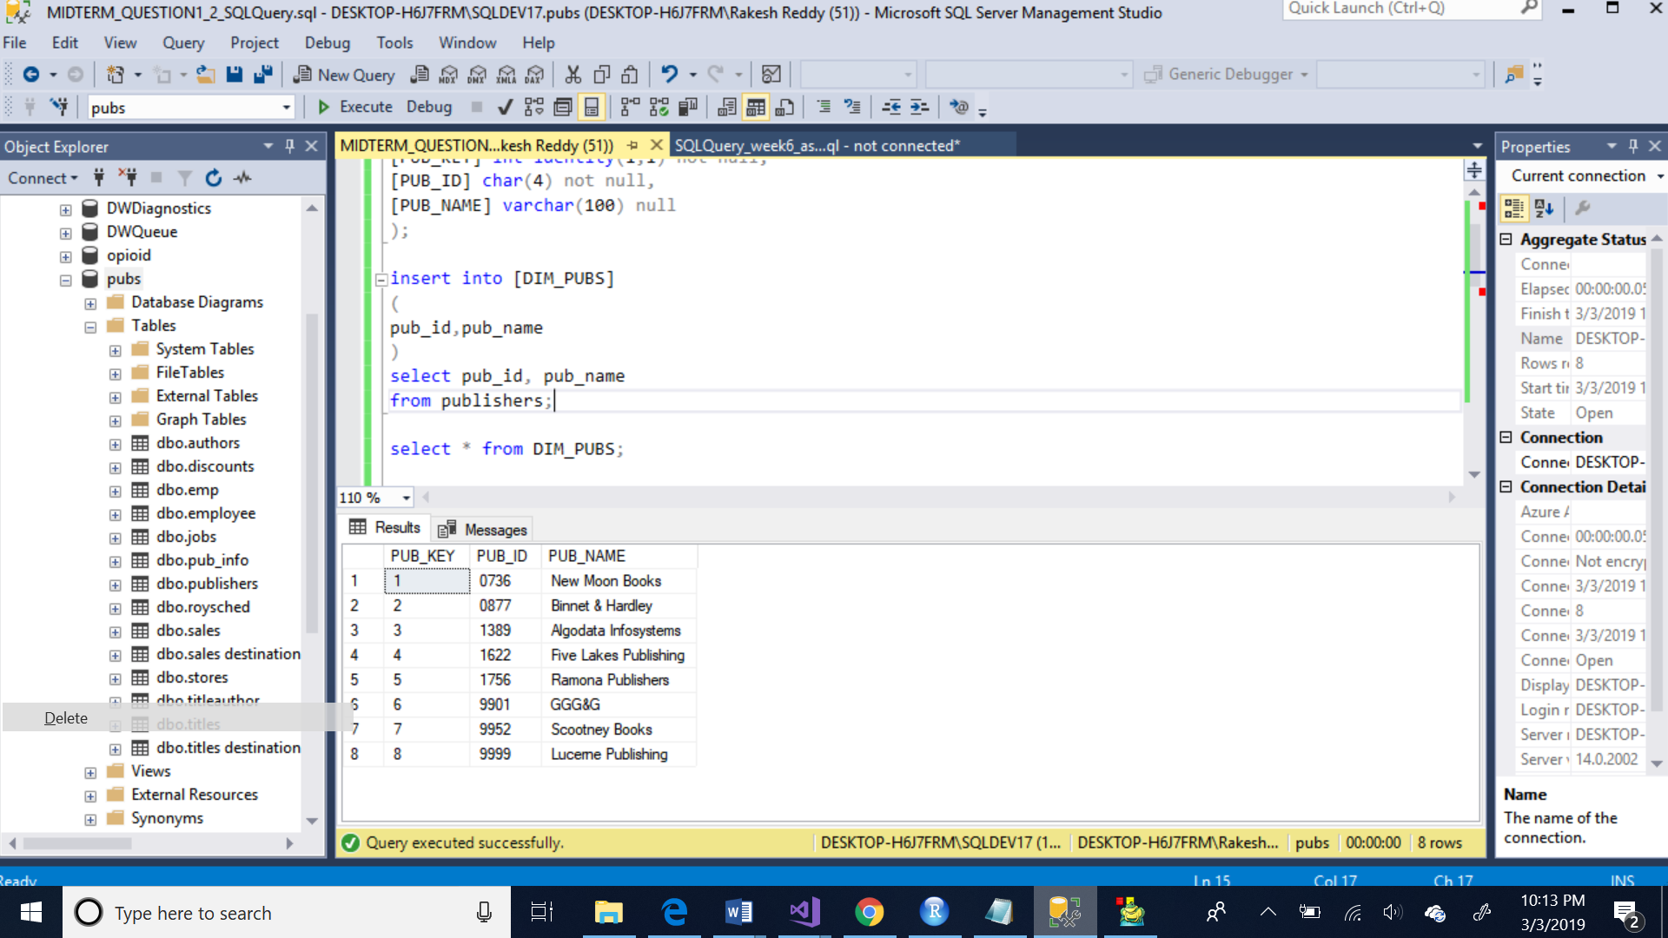

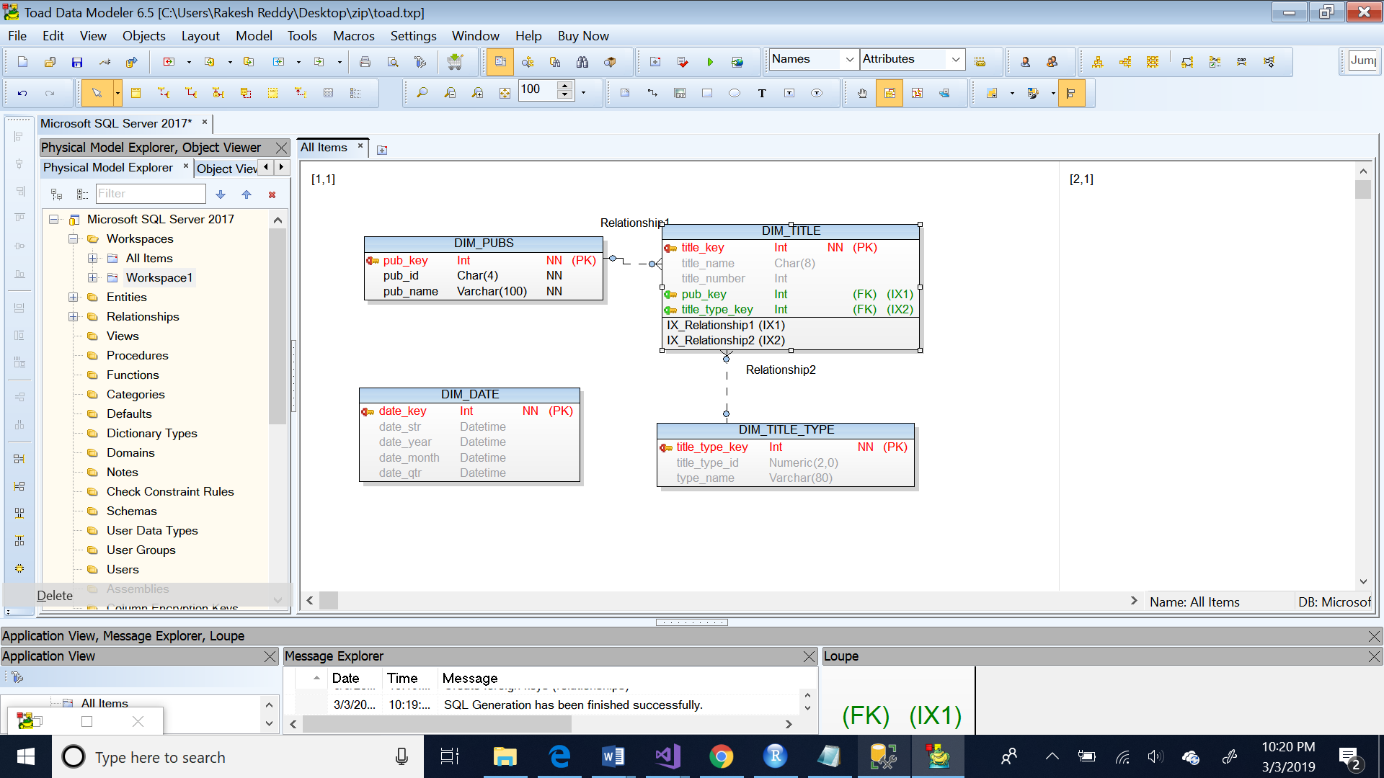

Below is the DDL SCRIPT:

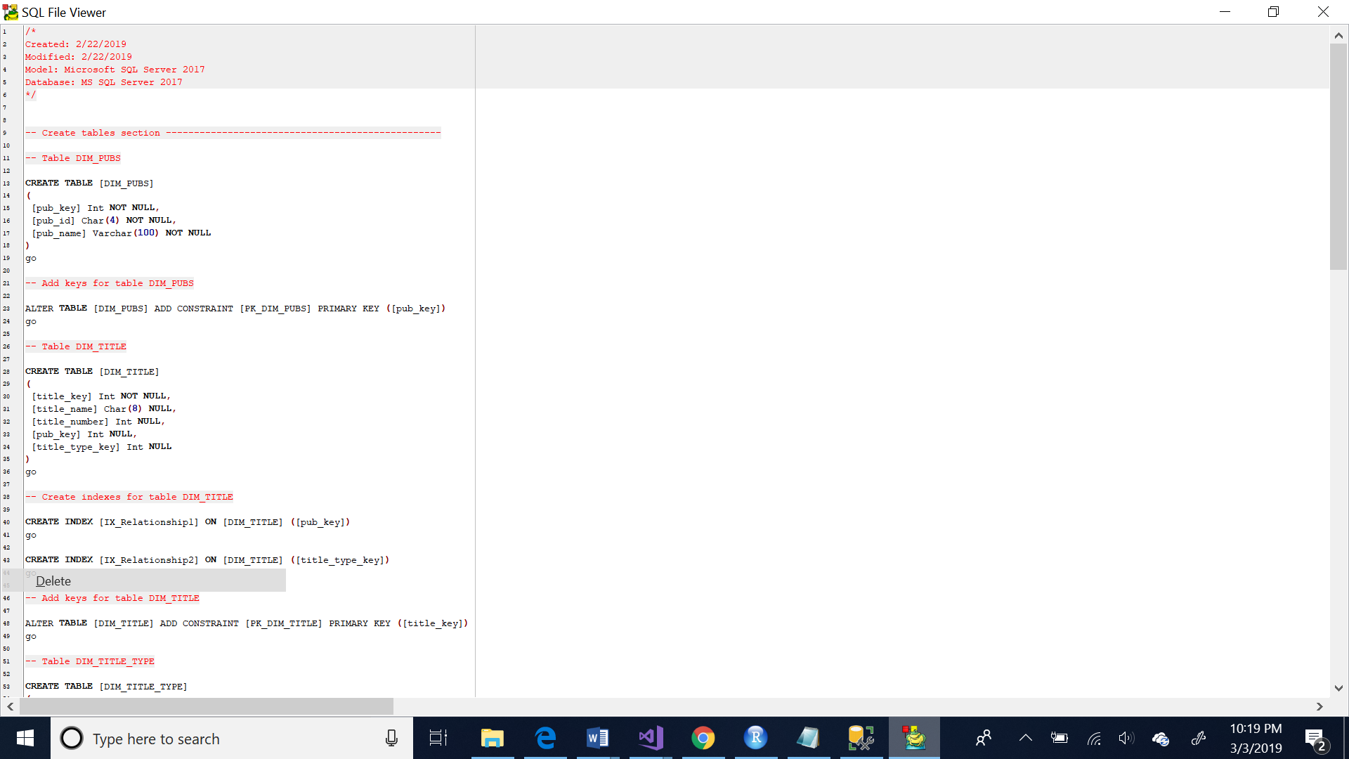

2)

-> Created dim_date with date_key as primary key using identity property which increases the value of the column automatically

Below is the code:

create table [DIM_DATE]

(

[DATE_KEY] int identity(1,1) not null,

[DATE_STR] char(8) not null,

[DATE_YEAR] int not null,

[DATE_MONTH] int not null,

[DATE_QTR] int not null

);

-> Inserted data into dim_date table using already existing sales table

Below is the code:

insert into [DIM_DATE]

(

DATE_STR,DATE_YEAR,DATE_MONTH,DATE_QTR

)

select

convert(char(8), ord_date,112) as DATE_STR ,

datepart(year,ord_date) as DATE_YEAR,

datepart(month,ord_date) as DATE_MONTH,

datepart(quarter,ord_date) as DATE_QTR

from sales

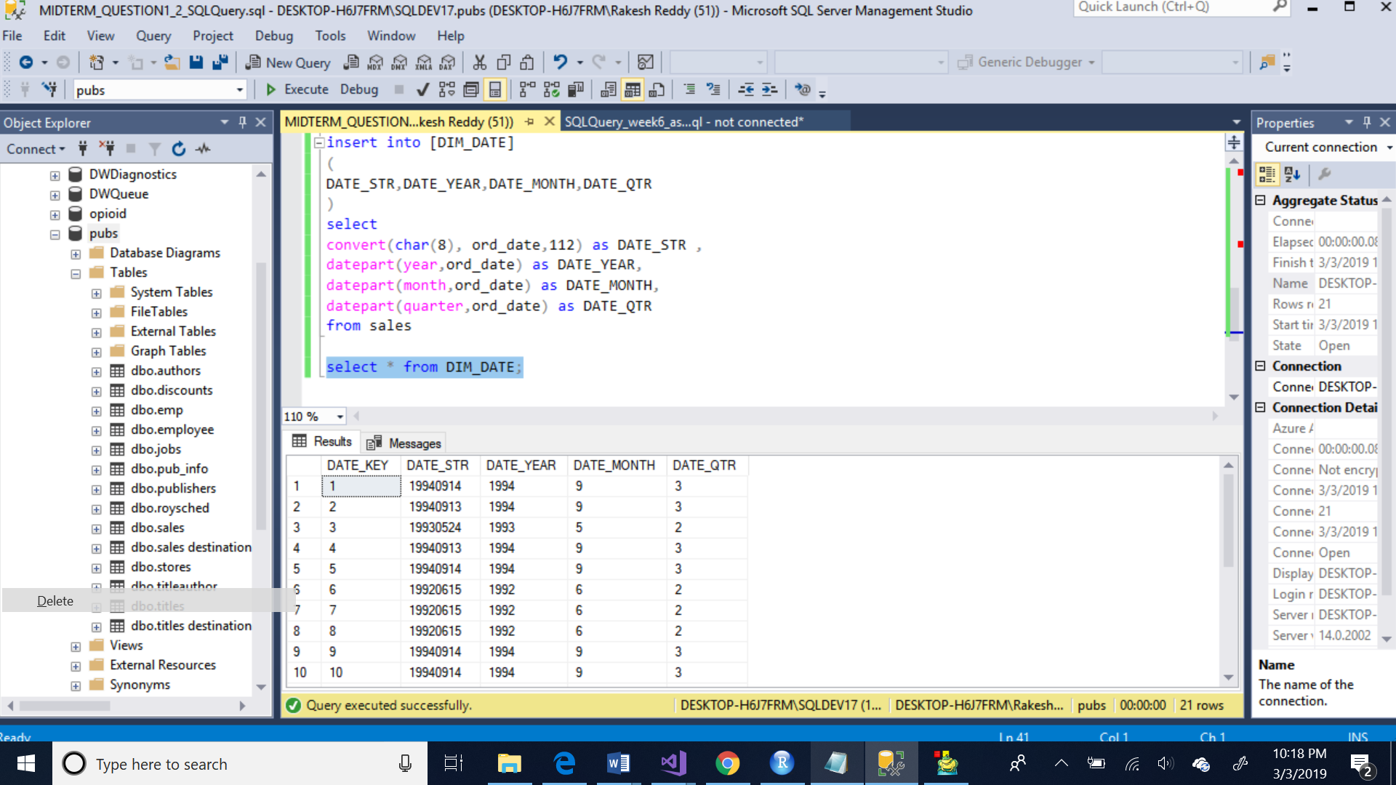

Below is the DDL SCRIPT:

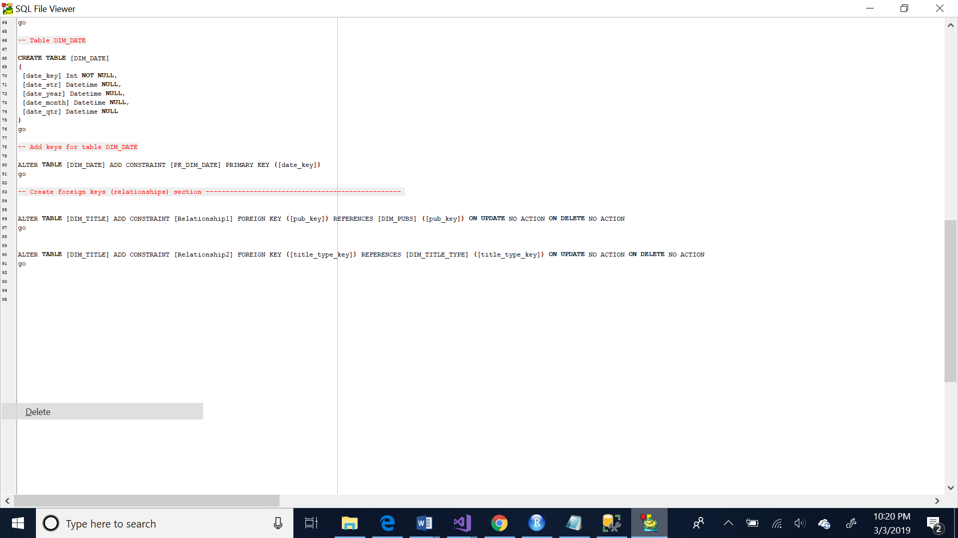

3)

Created dim_title dimension using titles table in ssis

Below is the data flow

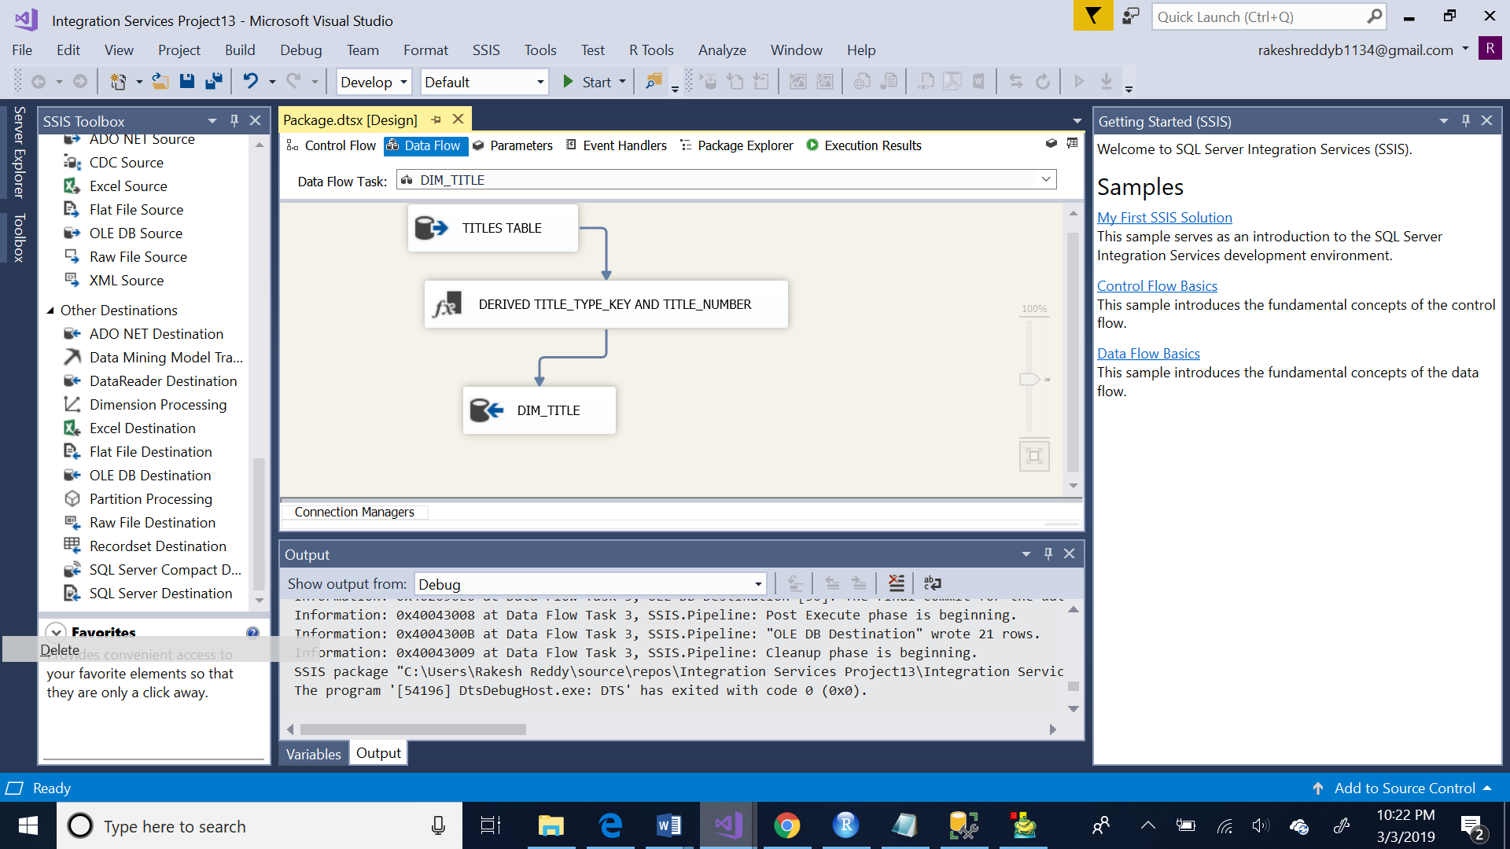

Derived two columns title_type_key and title_number from title_id using left() and right() functions

Below is the screenshot:

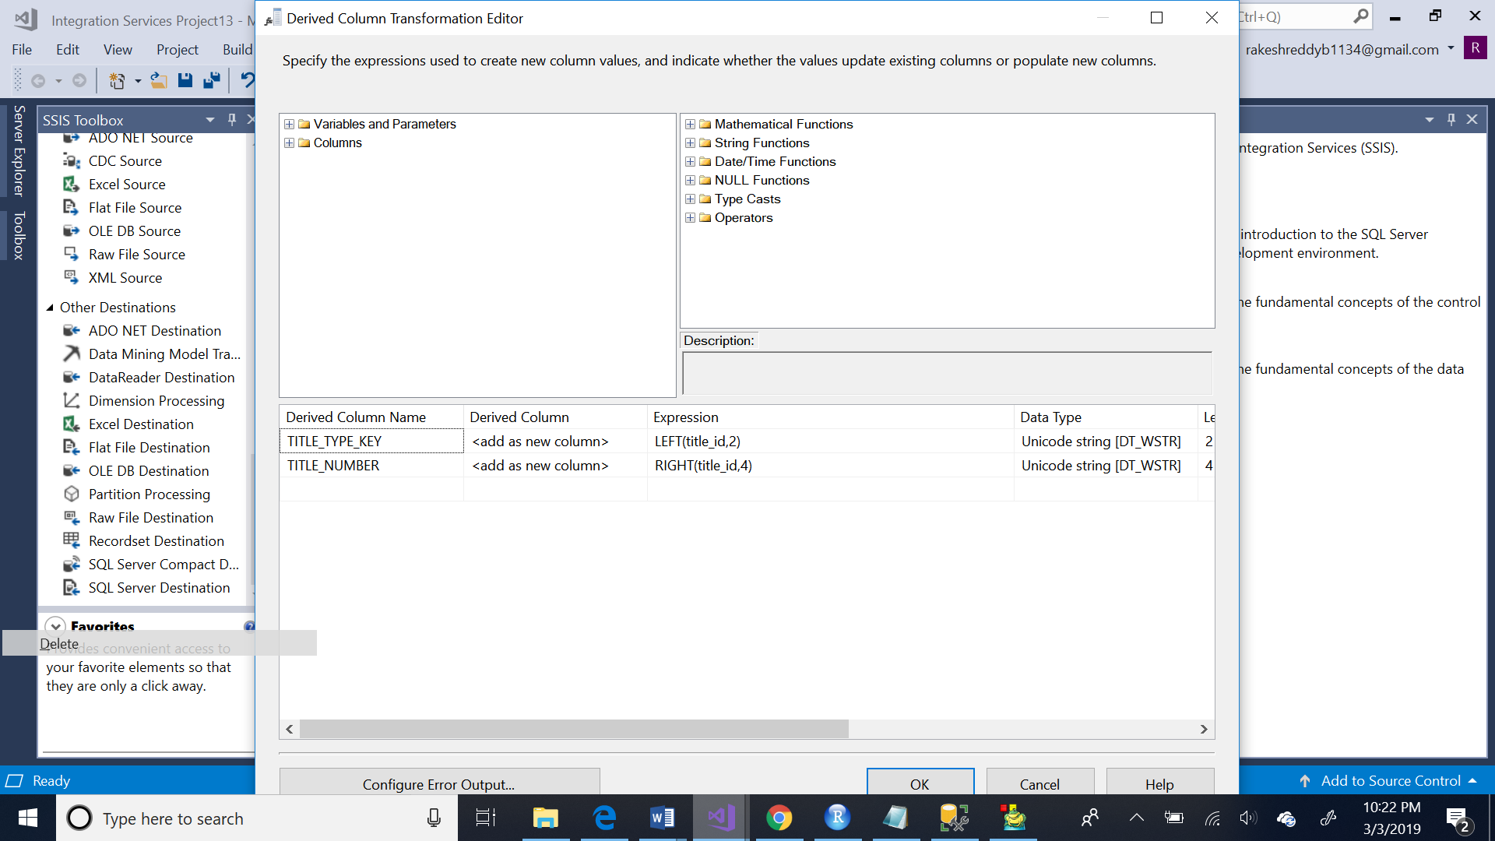

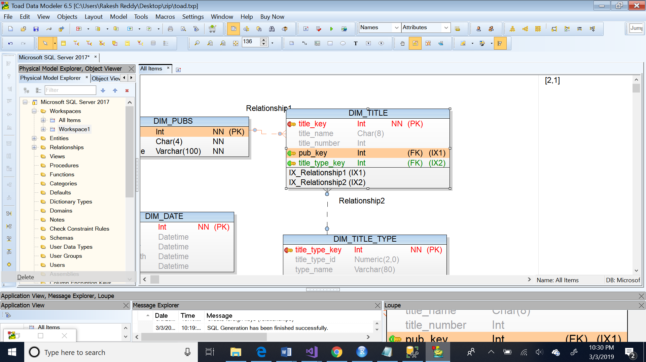

Below is the DDL SCRIPT:

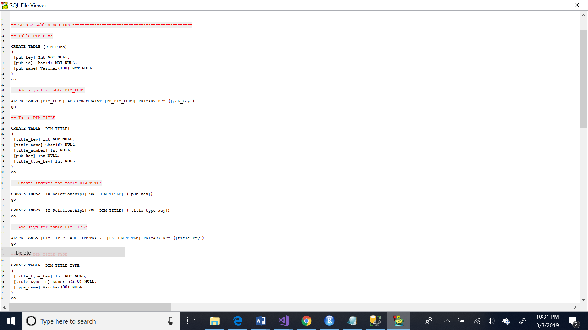

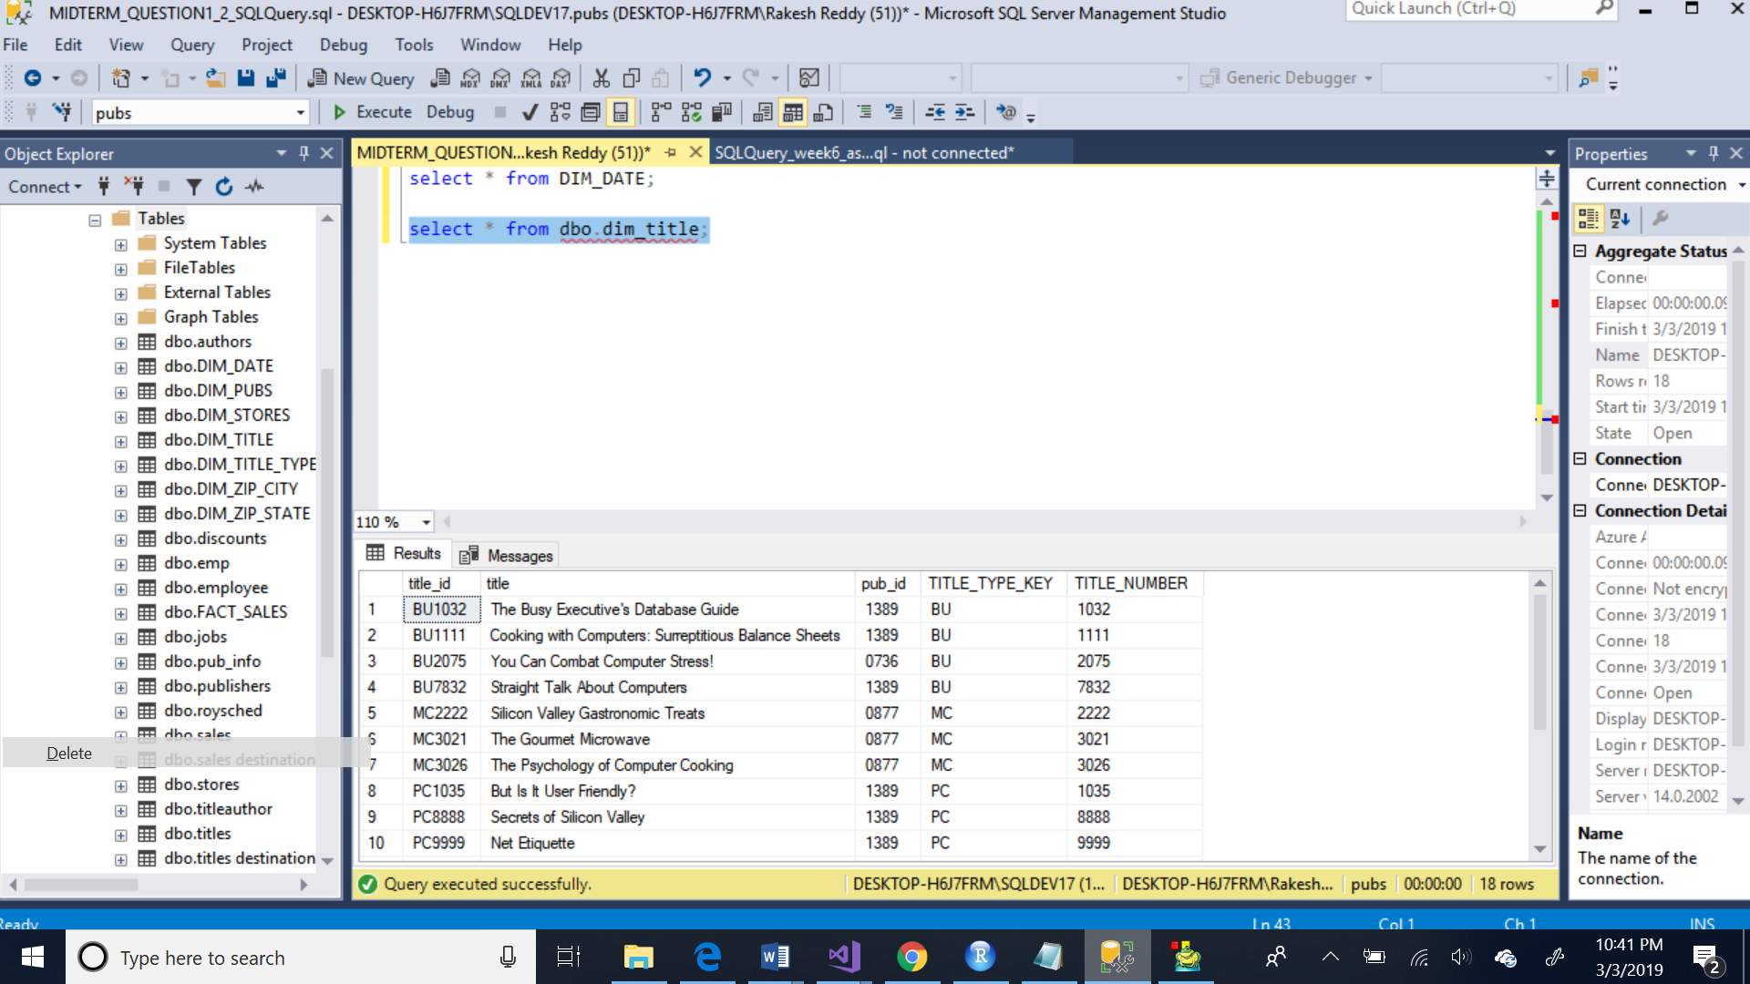

Created another dimension dim_title_type using titles table of pubs

Below is the data flow:

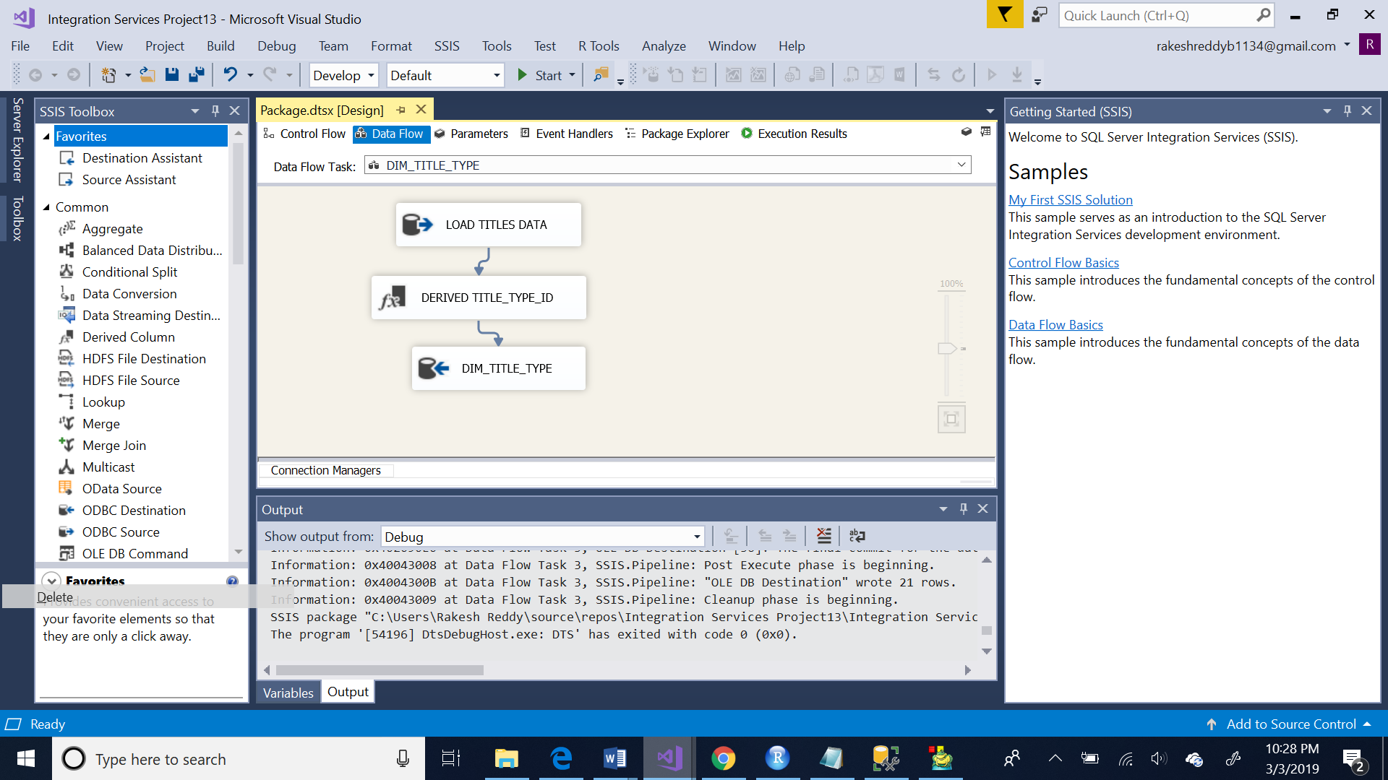

Derived title_type_id from title_id using left() function

Below is the screenshot:

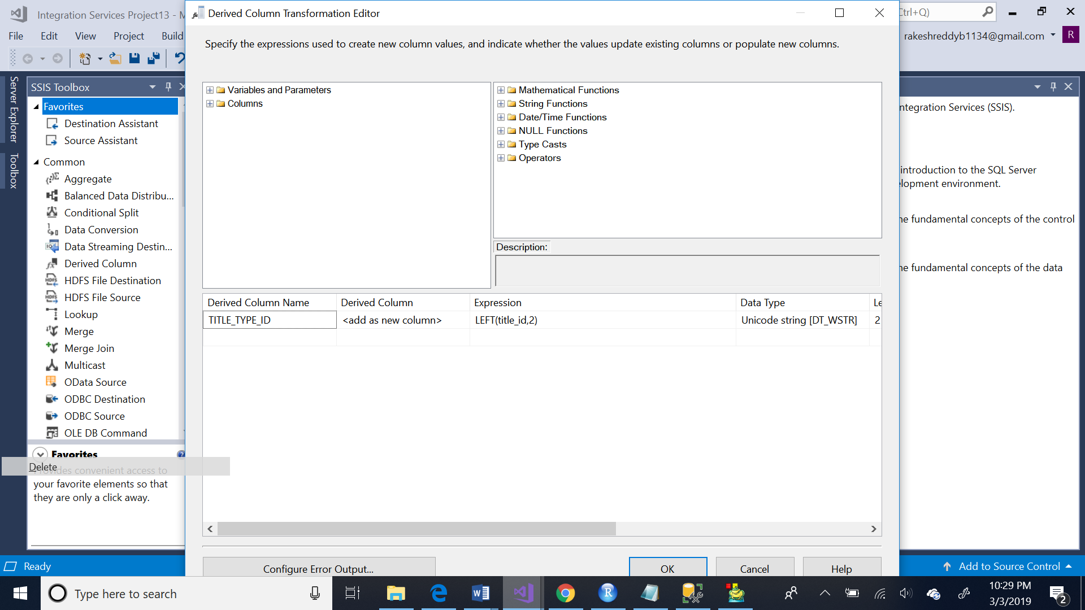

Below is the DDL script:

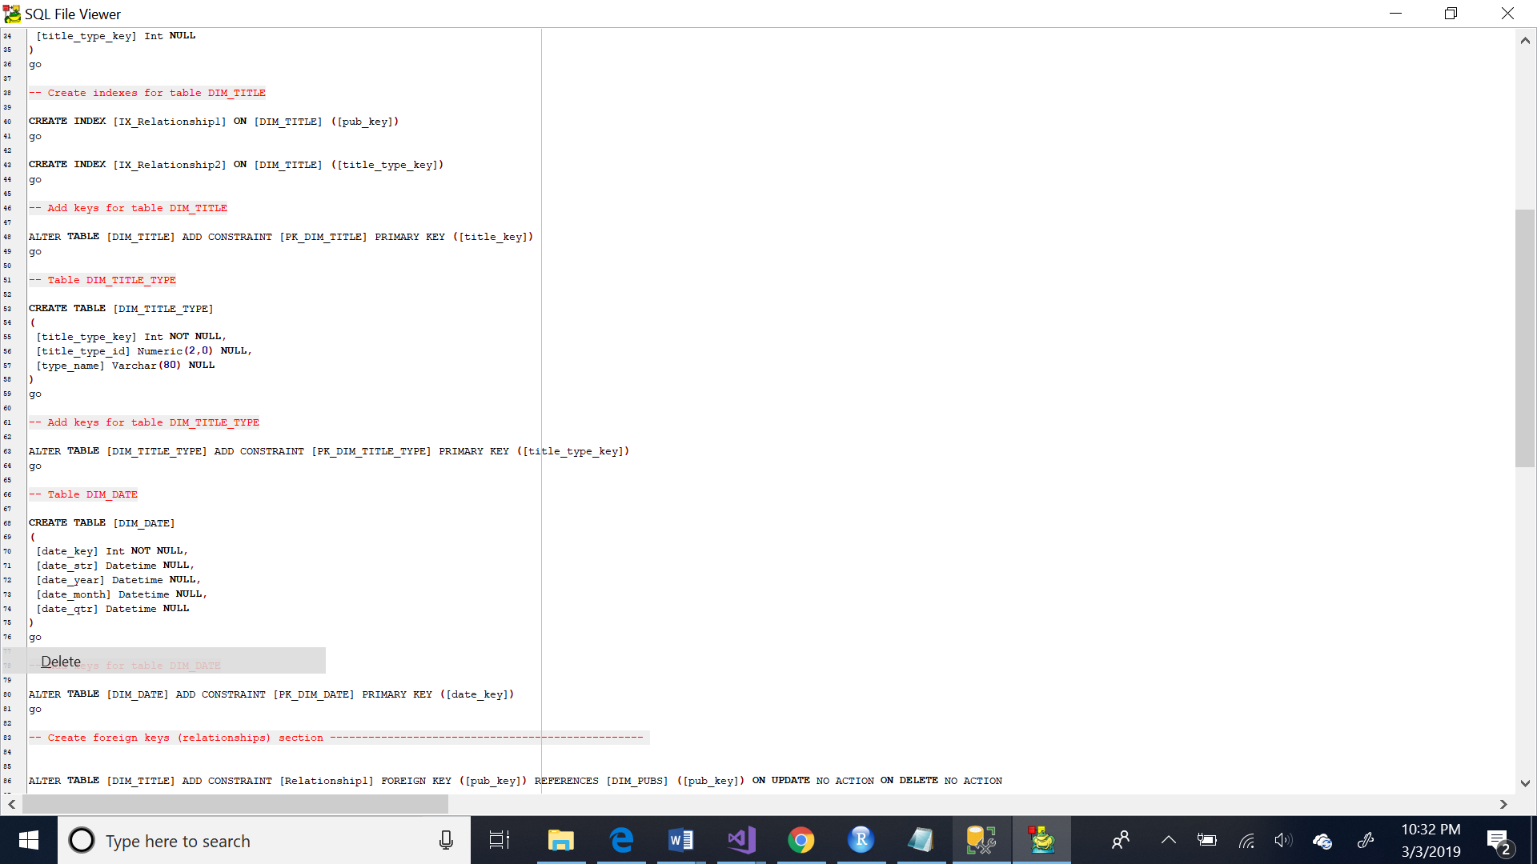

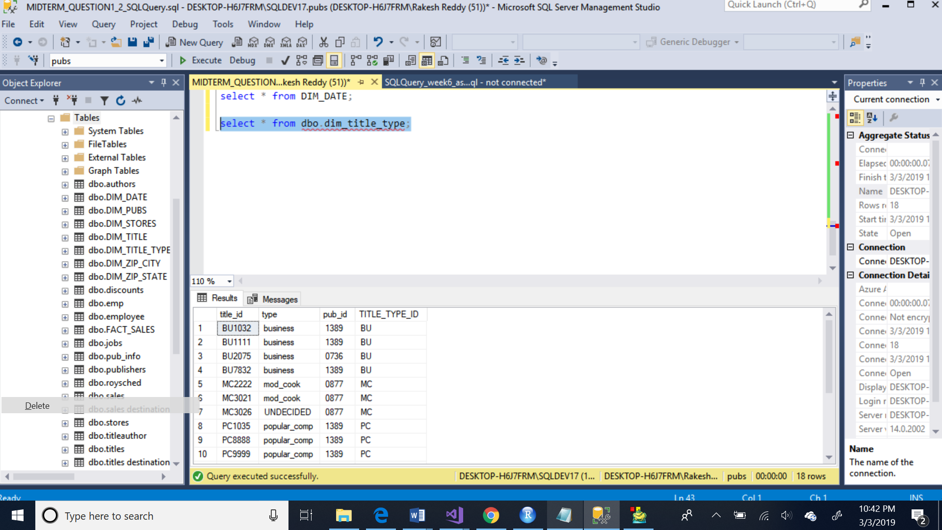

4)

Created three dimension tables ( dim_stores, dim_zip_city, dim_zip_state) using stores table of pubs

Below are the screenshots of ssis package:

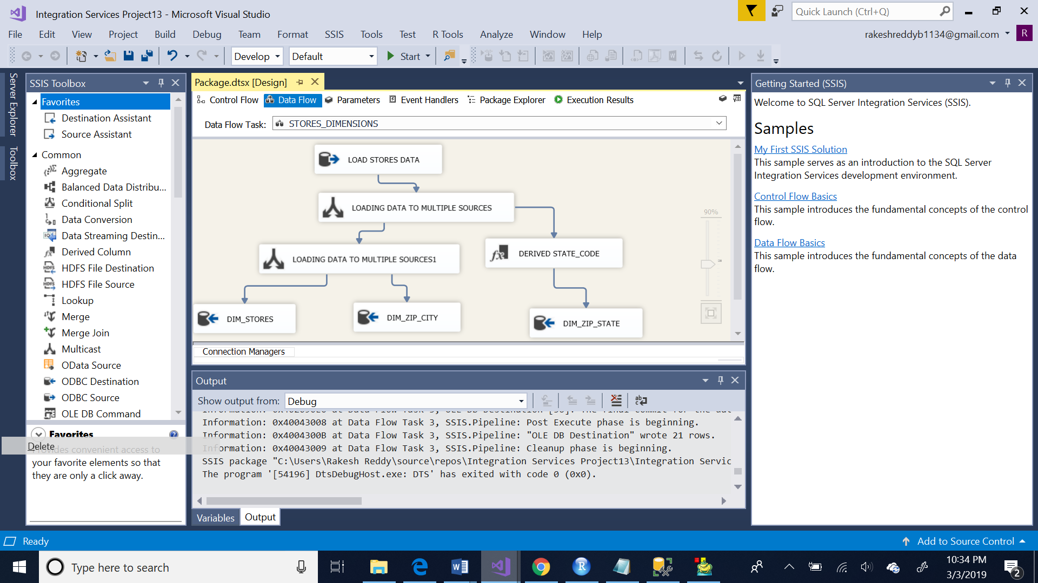

Below is the screenshot for derived column(state_code):

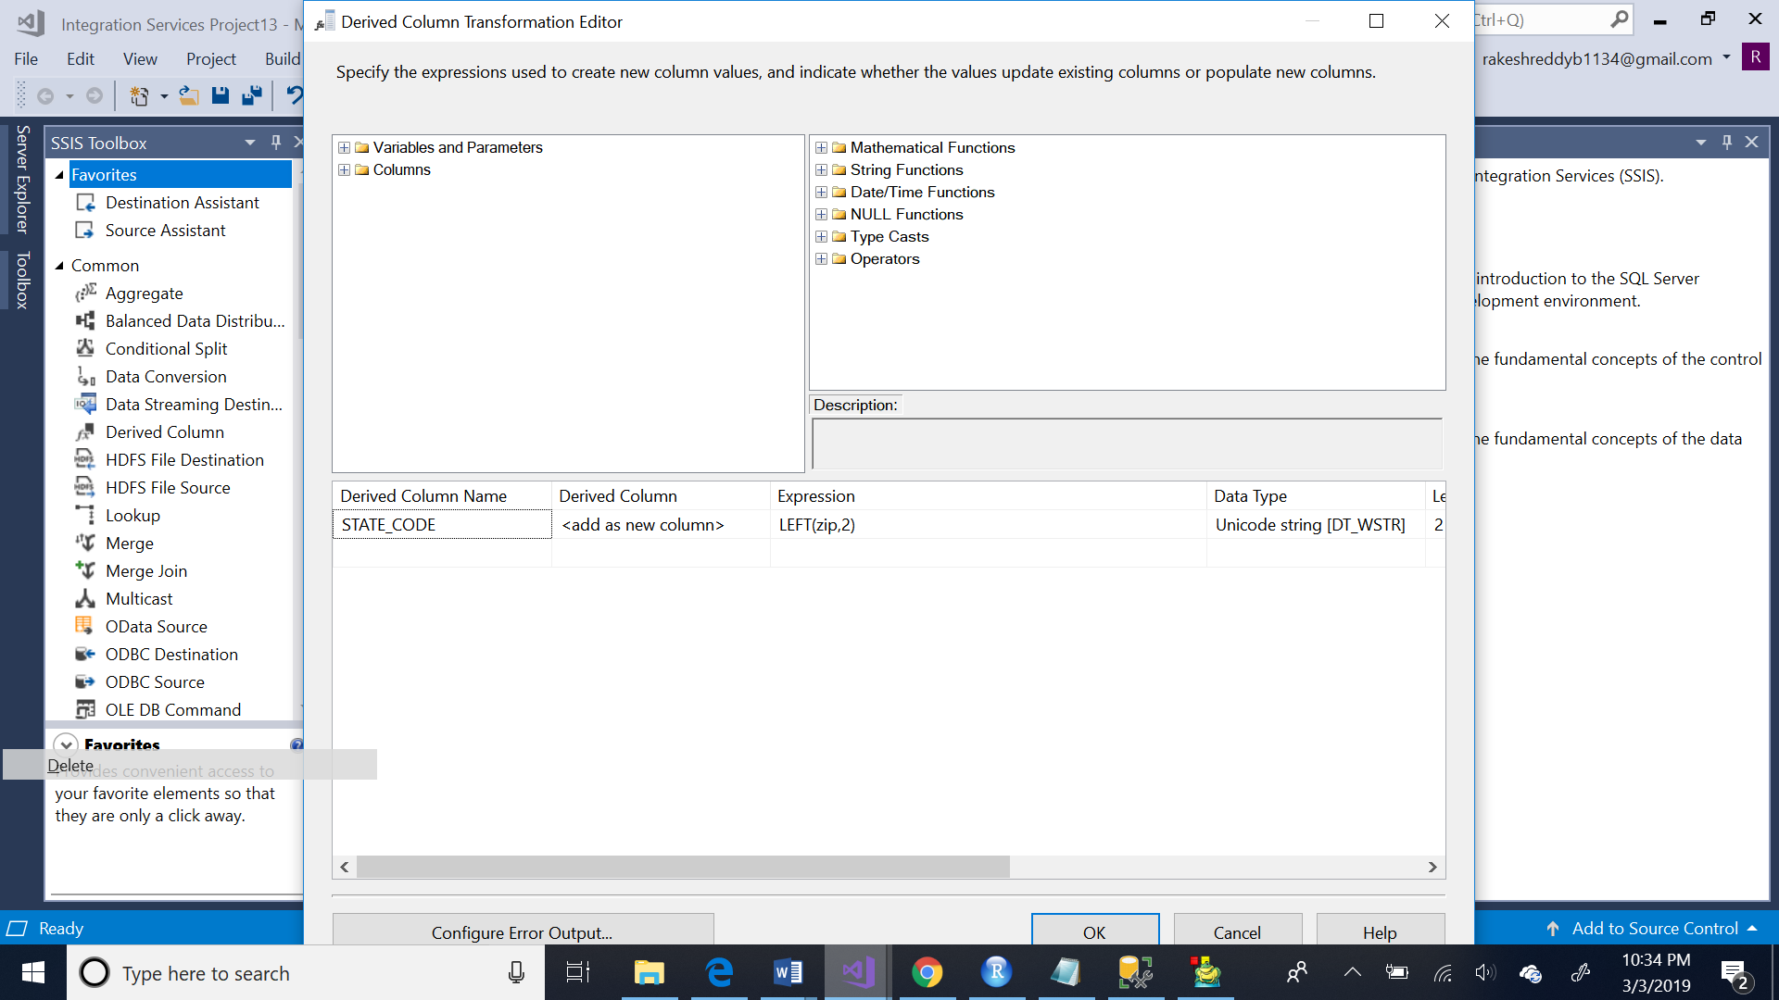

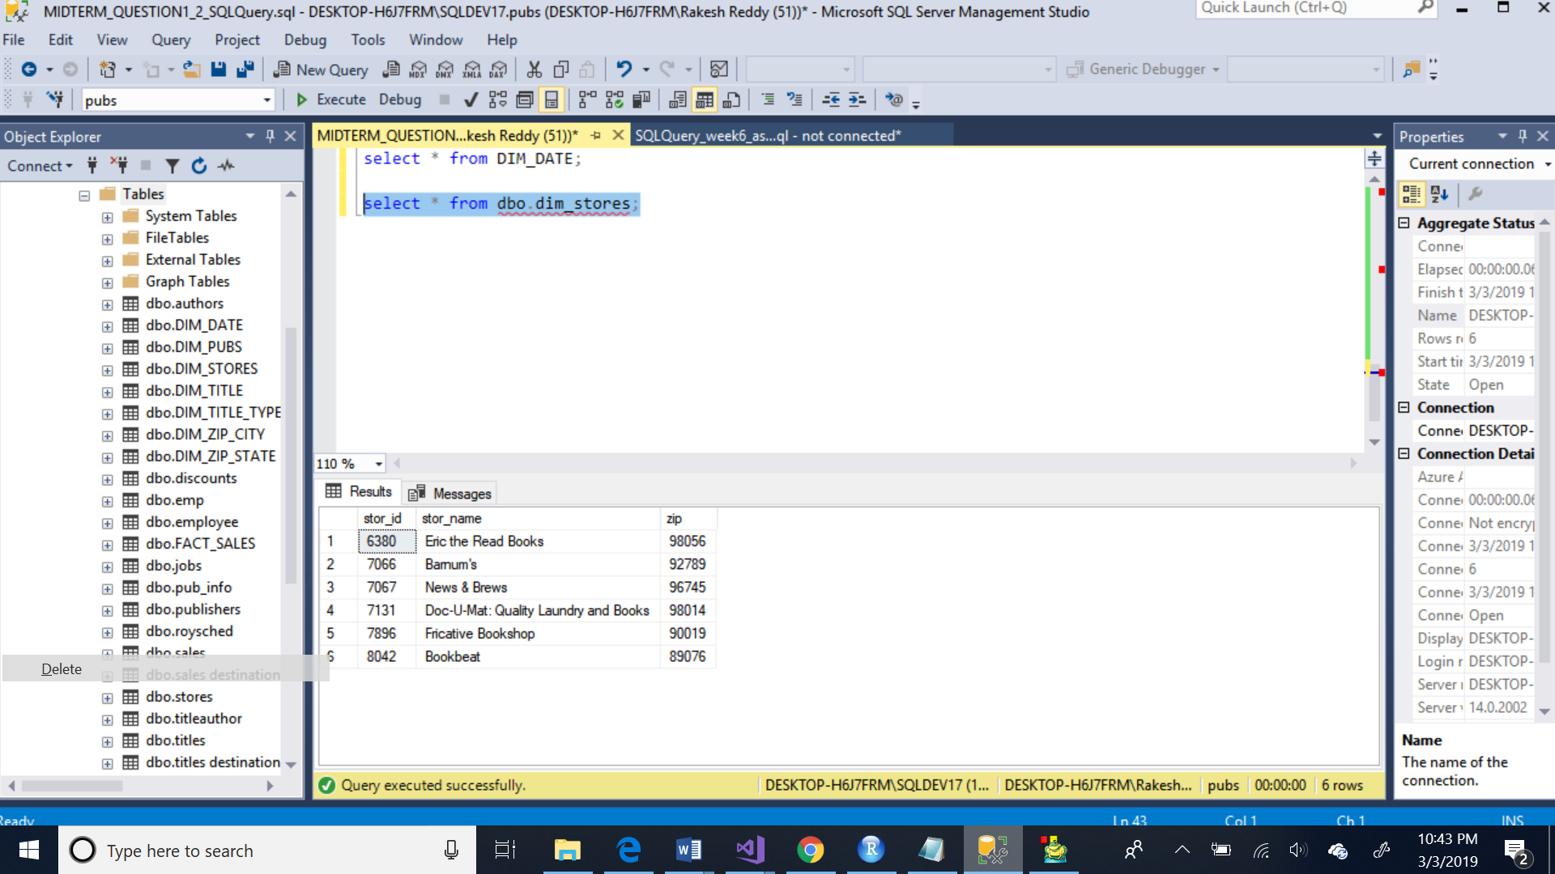

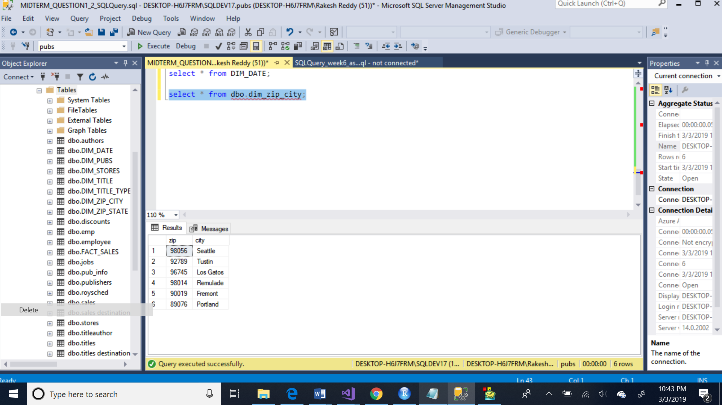

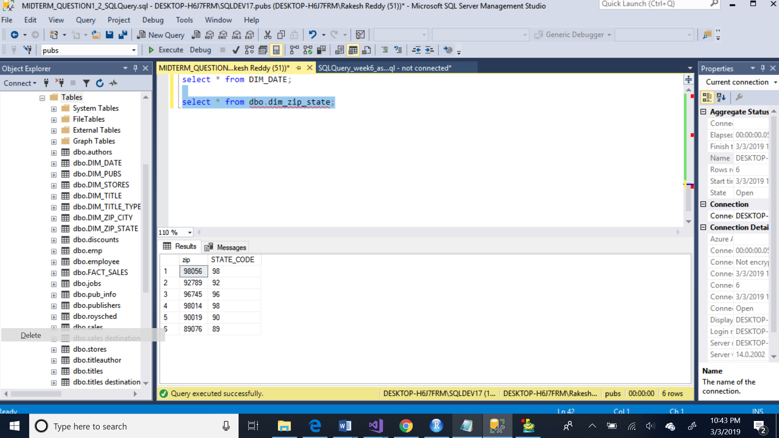

5)

Created fact table fact_sales using sales and titles tables pf pubs

Sorted the two tables using title_id and merged them

Below is the screenshot of ssis:

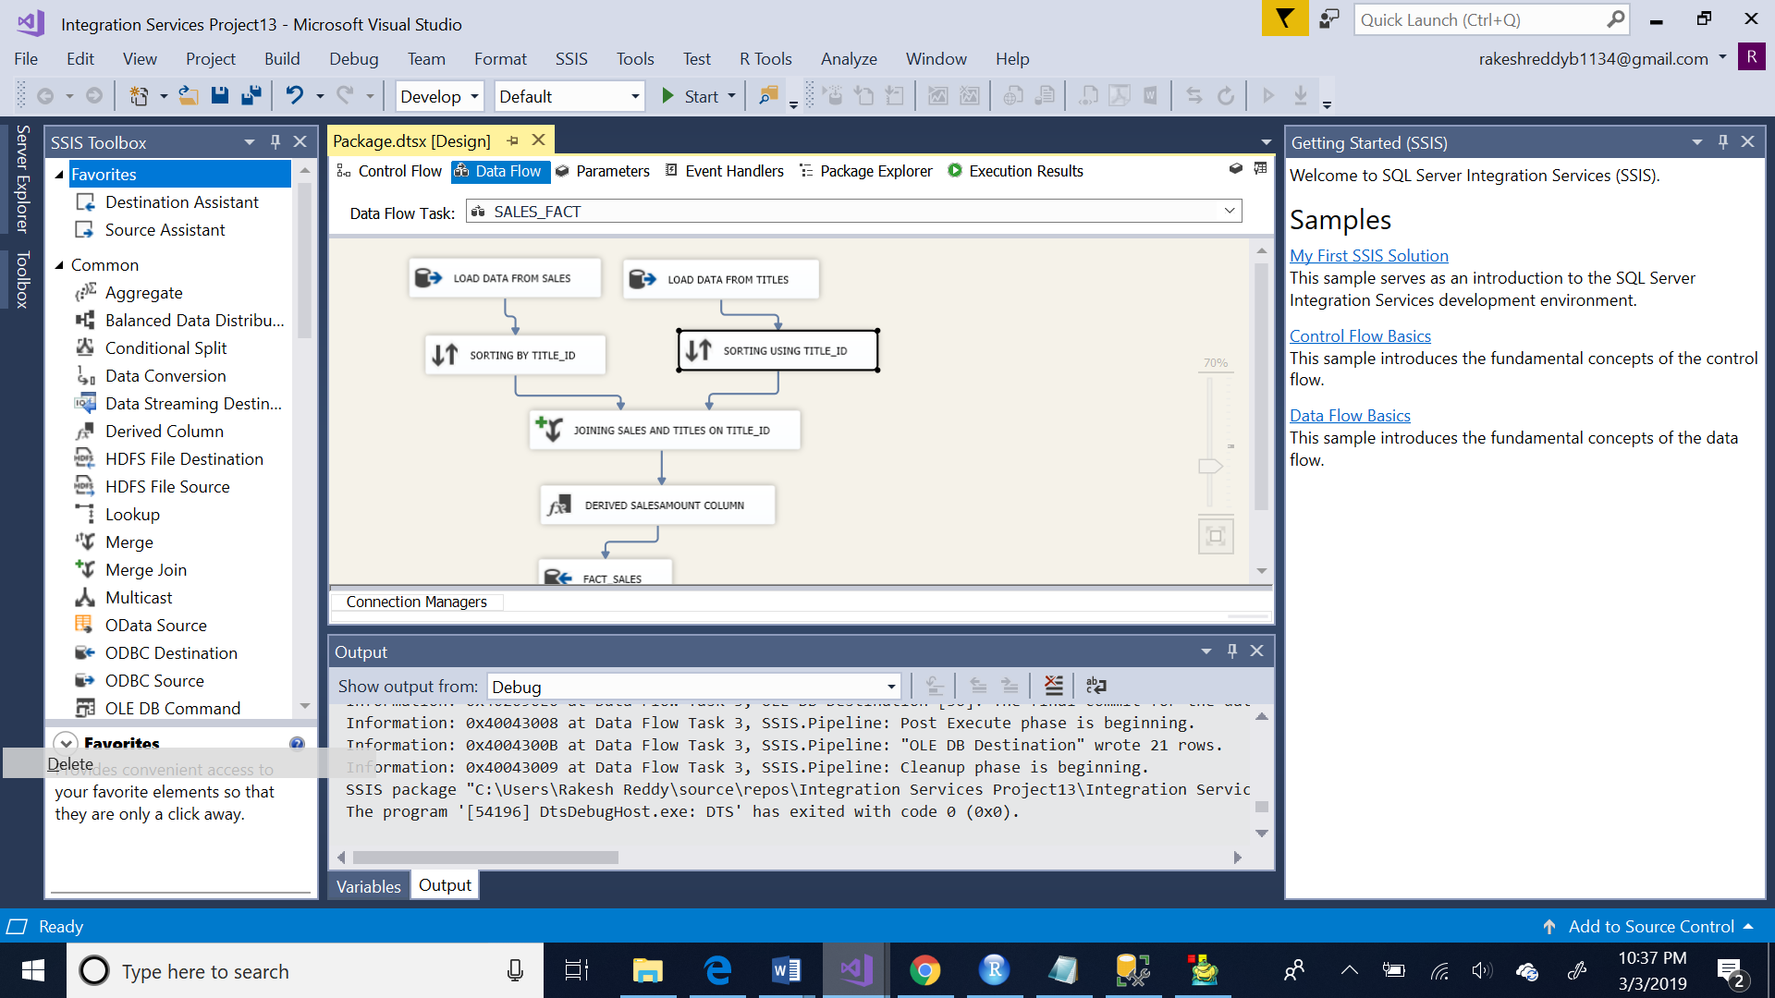

Below is the derived column salesamount which is ( quantity * price)

